

|  |  |  |  |  |  |  |  |  |
| --- | --- | --- | --- | --- | --- | --- | --- | --- |
|  | | | | | | | | |
|  | | Final Project: **Telecom Customer Retention/Churn Project** | | | | |  | |
|  |  | | | | | | |  |
|  | | | |  |  | | | |
|  | | | | Yash Suresh Upadhyay **101378657** |  | | | |
|  | | | | Date: 2023/12/12—Course Title: Work Integrated Project—Teacher’s name: Moe Fadaee |  | | | |
|  | | |  | | |  | | |



|  |  |  |  |
| --- | --- | --- | --- |
|  |  | | |
|  | INDEX | | | | | | |  |
|  |  | | |  |  | | |  |
|  |  | |  | | |  | |  |
|  |  |  | 1. Introduction ……………… 3 2. Methodology……………….. 4   2.1 Data Collection and Understanding ……………………4  2.2 Data Preparation and Feature Engineering…………….5  2.3 Exploratory Data Analysis (EDA)………………………………….5  2.4 Model Development………..8  2.5 Model Evaluation……………9  2.6 Recommendations and Implementations………………….9  2.7 Continuous Monitoring and Implementations…………………10   1. Results ………………………11 2. Conclusion …………………13 | | |  |  |  |
| [This Photo](https://www.thebluediamondgallery.com/tablet/c/customer-satisfaction.html) by Unknown Author is licensed under [CC BY-SA](https://creativecommons.org/licenses/by-sa/3.0/) | | | | |
|  |  |  |  |
|  |  |



**Customer Retention/Churn Analytics**

**____________________________**

Introduction to the Telecom Industry

The telecom industry, a dynamic and ever-evolving sector, plays a pivotal role in connecting individuals and businesses globally. In the contemporary landscape, telecom companies face challenges in retaining their customer base due to diverse factors such as competitive pricing, service quality, and evolving customer expectations. This project delves into the realm of telecom analytics, specifically focusing on customer retention and churn prediction. By harnessing the power of data analytics, we aim to unravel patterns and insights within a telecom dataset, contributing to strategic decision-making processes.

**Project Rationale**

Customer churn, the phenomenon of customers discontinuing services, poses a significant concern for telecom operators. Understanding the reasons behind churn and implementing effective retention strategies are critical for sustainability and growth. This project stems from the recognition that data-driven insights can revolutionize how telecom companies approach customer retention. Leveraging advanced analytics and predictive modeling techniques, our objective is to create a robust framework for identifying potential churners, enabling proactive measures to retain valuable customers.

**Project Scope and Objectives**

This project's scope encompasses the exploration and analysis of a telecom dataset rich in customer-centric information. Through the lens of data science, we aim to develop predictive models capable of anticipating customer churn. The objectives include identifying key features influencing churn, evaluating the effectiveness of historical retention strategies, and proposing data-driven interventions. By the project's conclusion, we anticipate delivering actionable insights that empower telecom stakeholders to make informed decisions, ultimately enhancing customer satisfaction and reducing churn rates.

**Methodology and Expected Outcomes**

Employing a combination of exploratory data analysis, machine learning algorithms, and predictive modeling, our methodology is designed to extract meaningful patterns from the telecom dataset. We will assess the performance of various models, striving for accuracy and interpretability. The expected outcomes involve the provision of actionable recommendations for telecom companies to refine their customer retention strategies. By embracing a data-driven approach, this project aspires to contribute to the telecom industry's resilience and its ability to proactively retain and engage customers in an era of unprecedented connectivity.

**METHODOLOGY**

1. Data Collection and Understanding

The initial phase of our methodology involves the acquisition and comprehension of the telecom dataset. We source data containing customer information, service usage patterns, and historical churn records. Preliminary exploratory data analysis (EDA) is conducted to gain insights into the dataset's structure, uncover correlations, and identify potential features influencing churn. This phase establishes a foundational understanding of the data landscape.

The data that I have used is from Kaggle. The data includes 21 columns and I have divided those columns into 4 different data frames contract, phone, personal, and the Internet. Following is the full list of each column present.

* **CustomerID**: A unique ID that identifies each customer.
* **Gender**: The customer’s gender: Male, Female
* **Senior** **Citizen**: Indicates if the customer is 65 or older: Yes, No
* **Married**: Indicates if the customer is married: Yes, No
* **Dependents**: Indicates if the customer lives with any dependents: Yes, No. Dependents could be children, parents, grandparents, etc.
* **Phone Service**:: Indicates if the customer subscribes to home phone service with the companyYes, No
* **Multiple** **Lines**: Indicates if the customer subscribes to multiple telephone lines with the company: Yes, No
* **Internet Service**: Indicates if the customer subscribes to Internet service with the company: No, DSL, Fiber Optic, Cable.
* **Online Security**: Indicates if the customer subscribes to an additional online security service provided by the company: Yes, No
* **Online Backup**: Indicates if the customer subscribes to an additional online backup service provided by the company: Yes, No
* **Device Protection Plan**: Indicates if the customer subscribes to an additional device protection plan for their Internet equipment provided by the company: Yes, No
* **Streaming TV**: Indicates if the customer uses their Internet service to stream television programming from a third party provider: Yes, No. The company does not charge an additional fee for this service.
* **Contract**: Indicates the customer’s current contract type: Month-to-Month, One Year, Two Year.
* **Paperless Billing**: Indicates if the customer has chosen paperless billing: Yes, No
* **Monthly Charge**: Indicates the customer’s current total monthly charge for all their services from the company.
* **Total Charges**: Indicates the customer’s total charges, calculated to the end of the quarter specified above.

Later in Data Preparation and analysis, we have added a few more columns which will be discussed later in the report.

1. Data Preparation and Feature Engineering

To enhance the dataset's quality and prepare it for modeling, we engage in rigorous data preprocessing. This includes handling missing values, encoding categorical variables, and normalizing numerical features. Feature engineering is employed to create new informative variables that may strengthen the predictive power of our models.

For instance, Get a grasp of what our four data frames look like

* Check for duplicates.
* Check for missing values.
* Check for troubling data types.

Based on the results the necessary preprocessing could be very short or more complicated

* Remove duplicates.
* Deal with missing values, either by trying to fill them or if there is no practical way to do so, removing them.
* Convert data into proper types.
* If necessary, encode the data frame for smoother analysis.

We may wish to combine all four of our datasets into a single data frame.

1. Exploratory Data Analysis (EDA)

EDA is a critical step to extract meaningful patterns and relationships from the data. Visualizations and statistical summaries are employed to unveil trends, outliers, and potential predictors of churn. The insights gained during EDA guide subsequent modeling decisions and help in formulating hypotheses to be tested.

Visualizing the data for the following:

* Check across specific metrics that at present are not clear but that can be determined after preprocessing.
* Generally, a histogram, box plot, and correlation matrix will be sufficient
* Check for outliers.
* Determine which of our features are likely to have a connection to our target and take a closer look at those.
* If encoding is deemed useful, we could check our class imbalance.
* If our classes are sufficiently imbalanced, we may wish to find an ideal threshold when building our models to achieve a higher accuracy.

The following are some visualizations that helped me understand more about customer patterns.

1. Monthly Charges by Customer

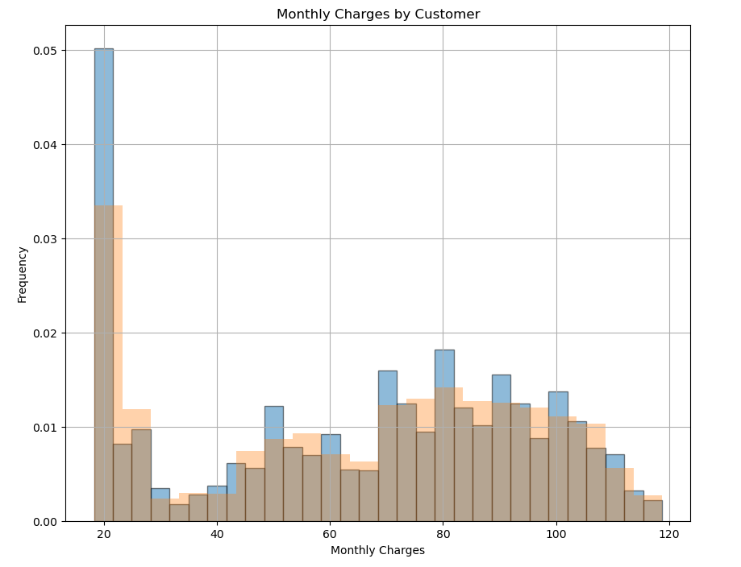

As we see the Monthly charges histogram its scattered and does not show clear patterns, but with an overlay of smaller bins we can see that there is a pattern. we can expect there to be three groups one who is spending between 25$-35$ (Saving category/lowest Plan), one category paying $50 , and another spending 80$.

1. Total Charges by Customer

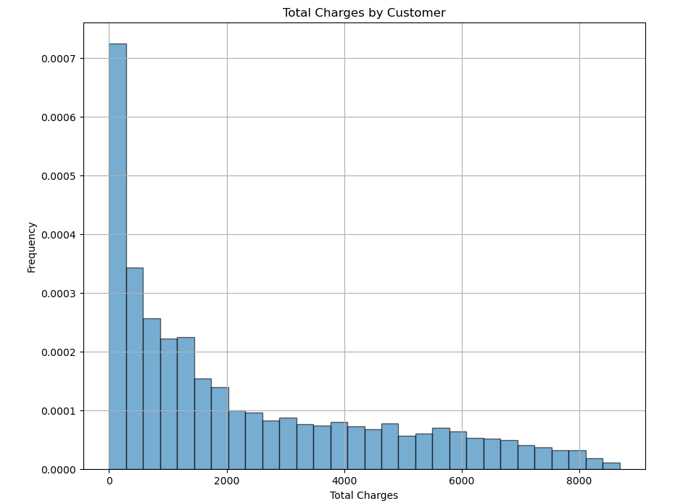

The histogram for total charges is clear and makes sense. We can expect a decline in the total charges amount paid by customers, seems like most of the customers are not staying longer with us or are in the category of minimal monthly cost.

1. Time spent by Customer:

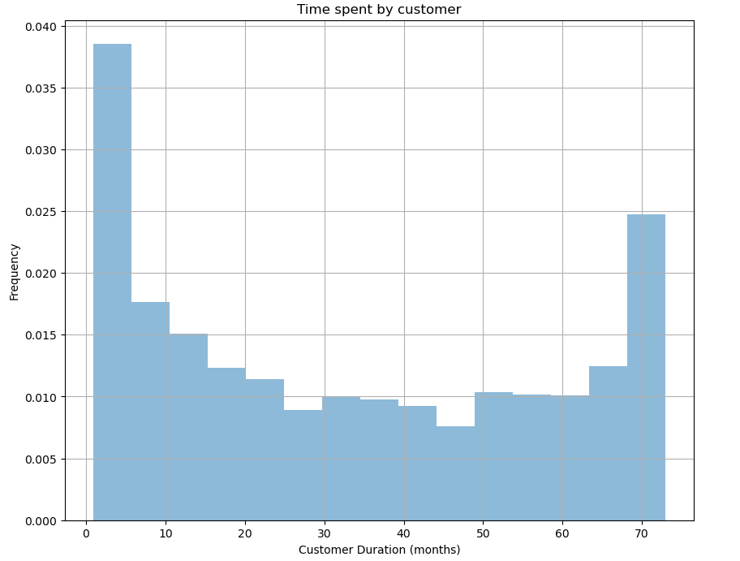

We can see most of our customers are living within 10 months of service and after that it seems to be fairly consistent. Likely we can conclude that if we hold a customer for at least six months to one year, they will retain services with us.

1. Correlation Matrix:

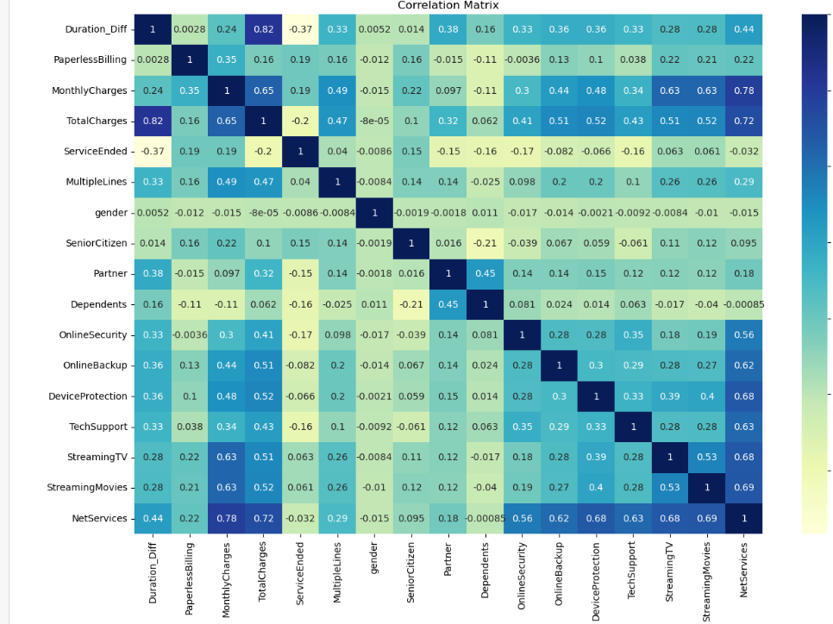

It appears that the strongest correlations that influence our targets are the ones related to price and the services being used. To summarize some of the insights from the correlation matrix about our target Service Ended:

1. The largest positive correlation to service being ended is the monthly price.
2. A similarly strong correlation is found if someone is using paperless billing. T
3. Senior citizens have a moderate correlation with ending their services. This could be unavoidable and the result of seniors being in their winter years. Though it is possibly something worth thinking about.
4. Security services have a negative correlation with ServiceEnded particularly the malicious website blocker. This suggests that our products are doing well with their security systems.
5. There also is a negative correlation between Tech Support and ServiceEnded, so our tech department seems to be working well. On the other hand, it is very slight but there is a small positive correlation between our streaming services and ServiceEnded = 1. This suggests that perhaps there is something we could improve there.
6. Model Development:

In this phase, we employ machine learning models to predict customer churn. Various algorithms such as logistic regression, decision trees, random forests, and gradient boosting are explored. The dataset is split into training and testing sets to evaluate model performance. Hyperparameter tuning and cross-validation are conducted to optimize model accuracy and generalizability. A comparison of different models ensures the selection of the most suitable approach.

* The project can be completed using a supervised learning model
* Before we begin training, we should do both a features/target split (our target is the 'EndDate' column)
* We also will want to split our data for testing purposes.
* We will do a 60/20/20 split with 60% of the data as a training set, 20% as a validation set, and 20% as the test set.
* Based on our outline, we will want an AUC-ROC of at least 0.75, but that is the bare minimum
* We should try to get as high as possible but will not expect to be able to improve much beyond 0.88.
* To get an idea of the time it might take processing the hyperparameter tuning, we should choose some different models.
  + Dummy model
  + Decision Tree
  + Linear Regression
  + Random Forest
  + XGBoost

1. Model Evaluation:

The developed models undergo thorough evaluation using metrics such as accuracy, precision, recall, and the area under the ROC curve (AUC-ROC). Interpretability of the models is prioritized to provide actionable insights for telecom stakeholders. We aim to identify key features driving churn predictions, allowing for the formulation of targeted retention strategies.

* Check the model against the test set for AUC-ROC and accuracy.
* If necessary, the model might need some additional tuning if it performed well against the validation set but poorly with the test set.
* We may need to use a larger training set if the model is performing particularly poorly compared to the test set, as a training set of 60% is already a bit low. We could try a 70/15/15.

1. Recommendations and Implementation:

Based on the outcomes of the models and their interpretations, we derive actionable recommendations for telecom companies. These may include personalized retention strategies, service improvements, or targeted promotional campaigns. The proposed interventions are designed to reduce churn rates and enhance customer satisfaction.

The final outcomes of all the model are:

* Logistic Regression Model:

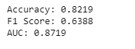

* Random Forest Classifier:

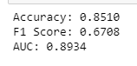

* Decision Tree Model:

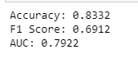

* XGBoost Model:

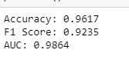

As we expected XGboost Gave the best result out of all the models.

1. Continuous Monitoring and Improvement:

The final stage involves the establishment of a continuous monitoring system. The models' performance is regularly assessed against new data, allowing for iterative improvements and adjustments. This adaptive approach ensures the longevity and effectiveness of the implemented retention strategies in a dynamic telecom landscape.

Through the systematic execution of these steps, our methodology aims to provide comprehensive insights and practical recommendations to empower telecom companies in addressing customer churn challenges proactively.

**Results**

* **Logistic Regression Model:**

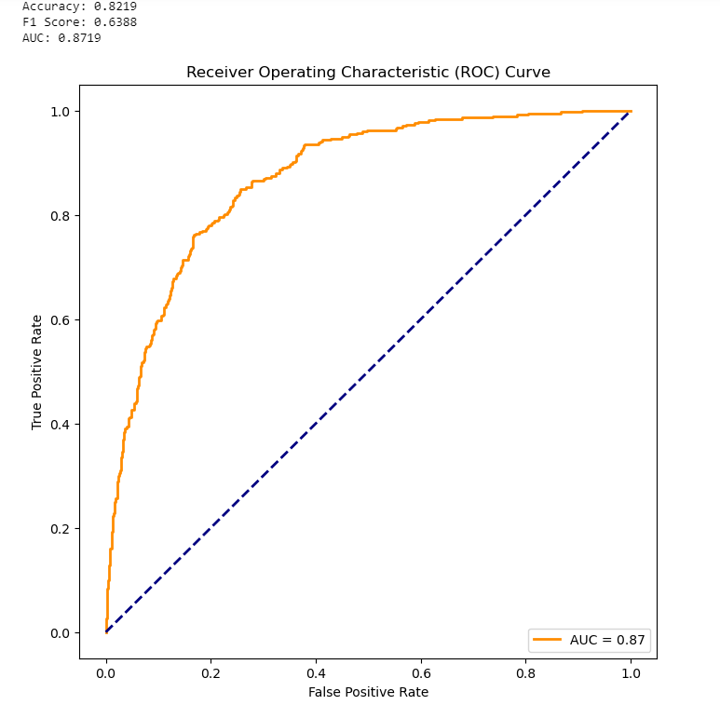

* **Random Forest Classifier:**

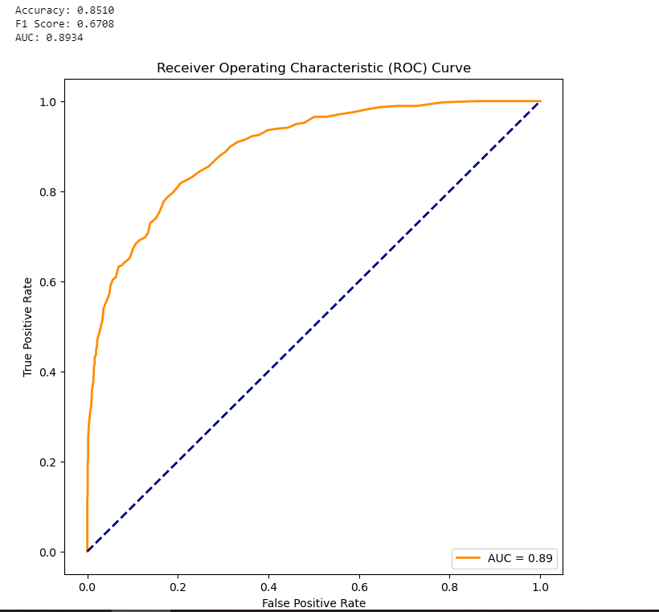

* **Decision tree model:**

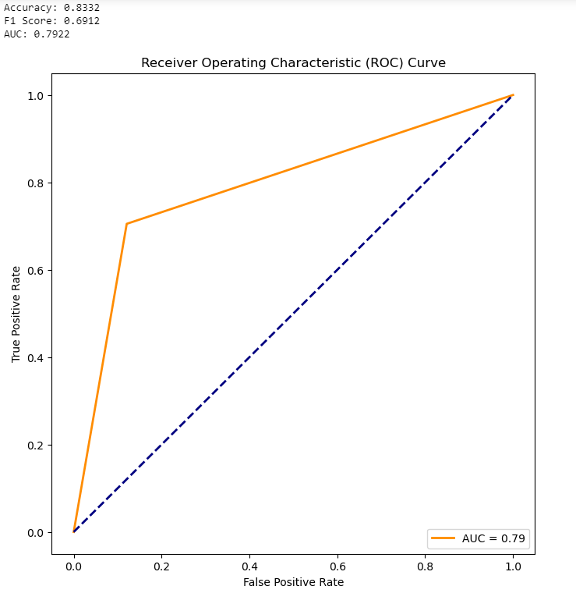

* **XGBoost:**

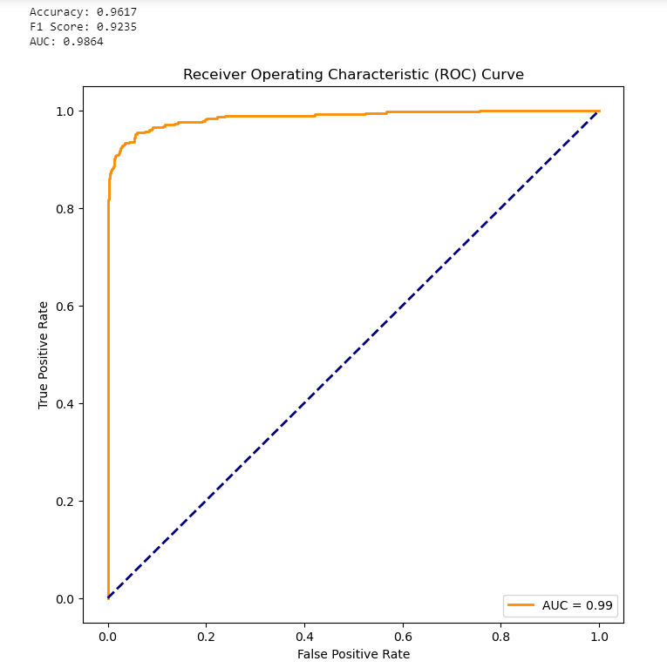

**Conclusion**

In our project we aimed to create a predictive model that will classify when a user is likely to cancel their services. We would determine our model a success based on the ROC-AUC score. A score lower than 0.75 was defined as too low, and an ideal score would be one higher than 0.88. We also wished to measure accuracy.

Since the goal of the model is to retain customers, we determined that we would prioritize a model even if it had slightly lower accuracy if its accuracy was more inclined towards returning a false positive, as a false positive would result in retaining customers with more certainty and a false negative means that we will have lost a customer that we otherwise might have kept.

First, we preprocessed our data to make all of the metrics usable for building our model. To create a full data set, we made a few key changes. We calculated the number of months a customer had been using the service, encoded our binary features, and counted the number of internet services a customer was utilizing. Doing this, we created a unified data set from our four separate data frames.

Afterwards, we performed exploratory data analysis. We created histograms that gave us an idea of customer paying practices as well as our general ability to retain customers. Then, we created a correlation matrix to see which of our features might be related to a customer continuing to use our service or to stop using it. We also checked our class imbalance to determine if we might wish to correct for imbalanced classes.

To create our models, we created a split with 60% of the data in our training set, 20% in a test set, and 20% in a validation set.

We made models across four styles a decision tree, a logistic regression, a random forest, and an XGboost. We first ran tests with no parameter tuning and our original data without accounting for imbalance. There, we created models that met both the standards for ROC-AUC and accuracy. We tried once more with up sampling and while accuracy did slightly rise it tended to be at the cost of returning more false negatives. As stated before, we would prioritize minimizing false negatives rather than purely aiming for accuracy and so we chose to use our initial models.

Because tuning our hyperparameters is rather time-consuming and we already had achieved a model that was tested with over 0.90 ROC-AUC, we determined that the model was more than sufficient as the one to use.

* The code is error-free and arranged in order of execution.
* Documentation is present directly preceding all code explaining its purpose.
* The data has been downloaded and prepared.
* Exploratory data analysis with graphical representation has been performed.
* The models have been trained.
* A final model has been created with an AUC-ROC of at least 0.75.

The final model is the XGBoost classifier model, trained on a subset of 60% of the total data set. It uses default hyperparameters. The ROC-AUC against the test set of 20% of the total data set with an accuracy of 0.95. With that accuracy, we can state that the model has approximately 1.29% false negative reports and 6.31% false positive reports.

What this means is that it only has approximately 1.29% chance of failing to identify when a customer is about to leave and a 6.31% chance of falsely identifying that a customer is about to leave when they are not. For the purposes of benefitting customer retention, the model works very well.